Monthly Status Report – May 2026
Millbrook Solar & Storage
Liam McAllister · 03 June 2026 · MB-PM-RPT-202605
Area | RAG | Comment
Overall | Green | Consultation #2 on 20 May drew 212 attendees and 202 responses.
Cost | Green | Development spend EUR 1.88 m of EUR 3.10 m budget (61 %)
Schedule | Amber | Planning decision Q1 2027 – on track
Stakeholders | Green | Consultations held: 2 of 3

Summary
Consultation #2 on 20 May drew 212 attendees and 202 responses. Layout Rev C (85 MWp) was frozen for submission and the EPC tender was issued on 22 May.

Key figures
Metric | Value
Capex estimate (P50) | EUR 78.0 m
Open risks | 17
Consultation responses to date | 299
Development spend to date | EUR 1.88 m

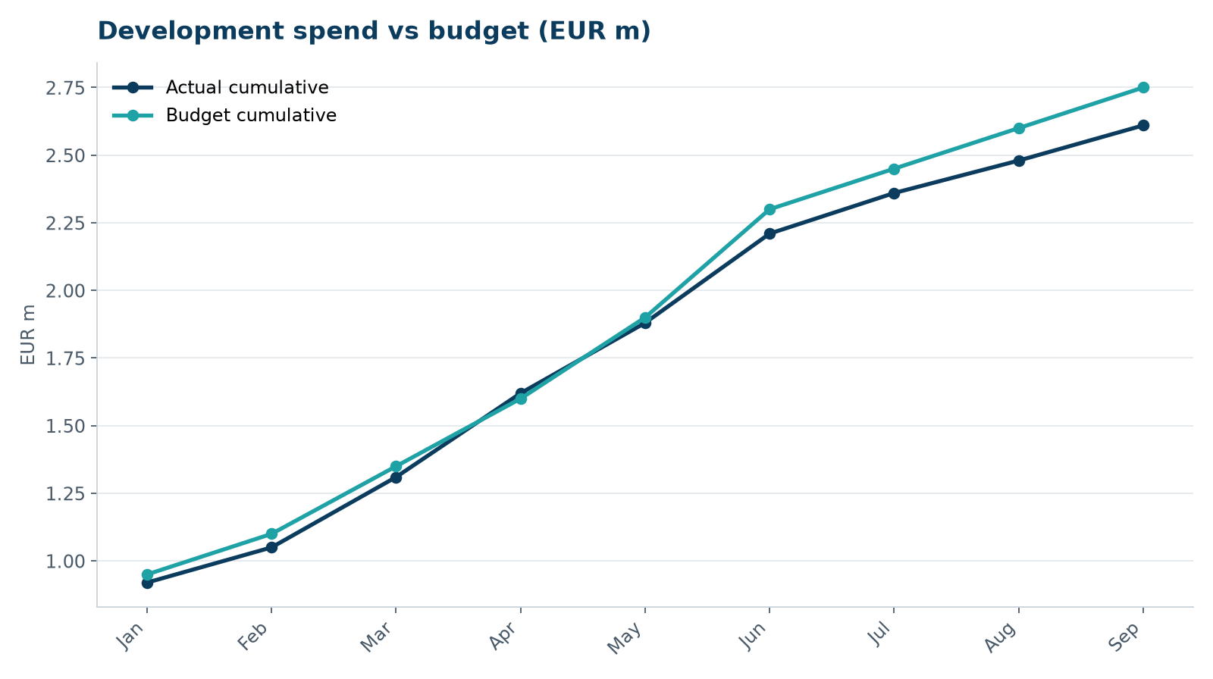
Development spend vs budget

Next month
- Submit planning application
- Finish breeding bird survey
- Answer EPC bidder clarifications

